1. **BOOKS (Details about books in library):**

|  |  |
| --- | --- |
| **Column** | **Datatype** |
| Book_ID | VARCHAR2(10 CHAR) |
| Book_Title | VARCHAR2(300 CHAR) |
| Book_Author | VARCHAR2(50 CHAR) |

2. USERS (Users includes both staff and students):

|  |  |
| --- | --- |
| Column | Datatype |
| USER_ID | VARCHAR2(10 CHAR) |
| NAME | VARCHAR2(50 CHAR) |
| DESIGNATION | VARCHAR2(10 CHAR) |

**3. ISSUES (Records for books issued):**

|  |  |
| --- | --- |
| **Column** | **Datatype** |
| Issue_ID | Number(10,0) |
| Book_ID | VARCHAR2(10 CHAR) |
| Book_Title | Varchar2(100 CHAR) |
| Borrower_ID | VARCHAR2(10 CHAR) |
| Borrower_Name | Varchar2(100 CHAR) |
| Borrower_Designation | Varchar2(50 CHAR) |
| Issue_Date | DATE |
| Date_Expiry | DATE |

**4. RETURNS (Records for books returned):**

|  |  |
| --- | --- |
| **Column** | **DataType** |
| Return_ID | Number(10,0) |
| Book_ID | VARCHAR2(10 CHAR) |
| Borrower_ID | VARCHAR2(10 CHAR) |
| Borrower_Name | Varchar2(100 CHAR) |
| Issue_Date | DATE |
| Deadline_Date | DATE |
| Return_Date | DATE |
| Delay | Number(10,0) |

**5. FINE (Records for fine against books):**

|  |  |
| --- | --- |
| **Column** | **DataType** |
| Fine_ID | Number(10,0) |
| Book_ID | VARCHAR2(10 CHAR) |
| Book_Title | Varchar2(100 CHAR) |
| Borrower_ID | VARCHAR2(10 CHAR) |
| Borrower_Name | Varchar2(100 CHAR) |
| Delay | NUMBER(19,9) |
| Fine_Amount | NUMBER(39,19) |

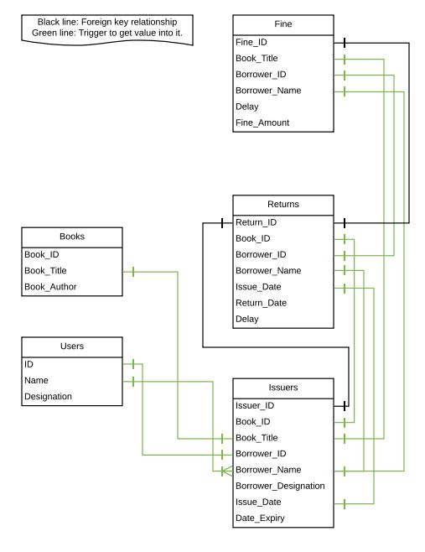

Following are two points which were set as standard while using the delay logic:

For staff members, the maximum delay in return can be of 5 days.( wenas krnen oni code eke)

For students,  the maximum delay in return can be of 4 days. .( wenas krnen oni code eke)

You can change this value by changing the value in below trigger **(ISSUE_EXPIRY)**: